Predlog Poena:

Konačno poena:

Internet jezici i alati 1

Ispitni Projekat

Datum: 27.12.2019.

Danijela Zorjan, IT5/18

**Pitanja:**

**Projekat**

**Kratak opis:**

Primenom HTML – a i CSS – a kreiran je web sajt na temu *Sweet Cake Bakery*. Sajt ima 5 stranica. Responsivan je.

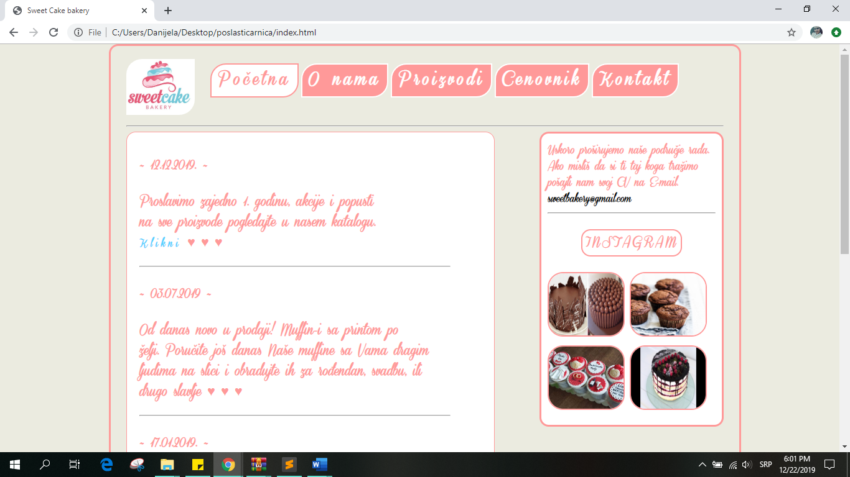

*Slika 1. Početna stranica*

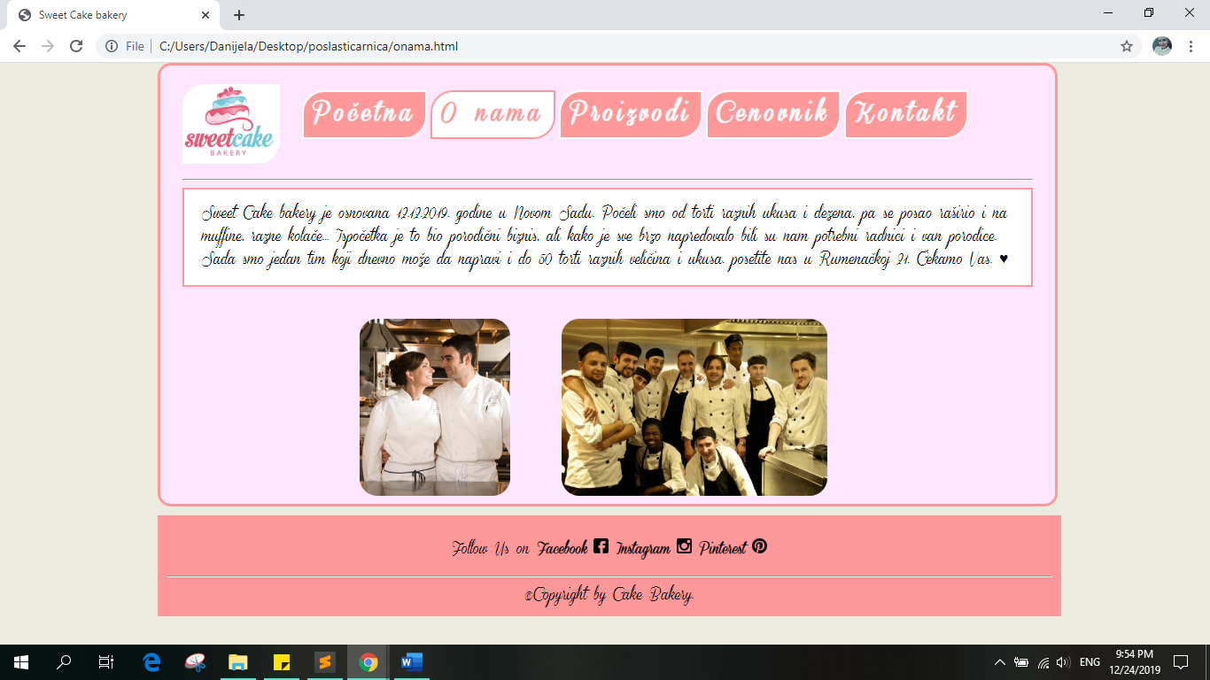

*Slika 2. O nama stranica*

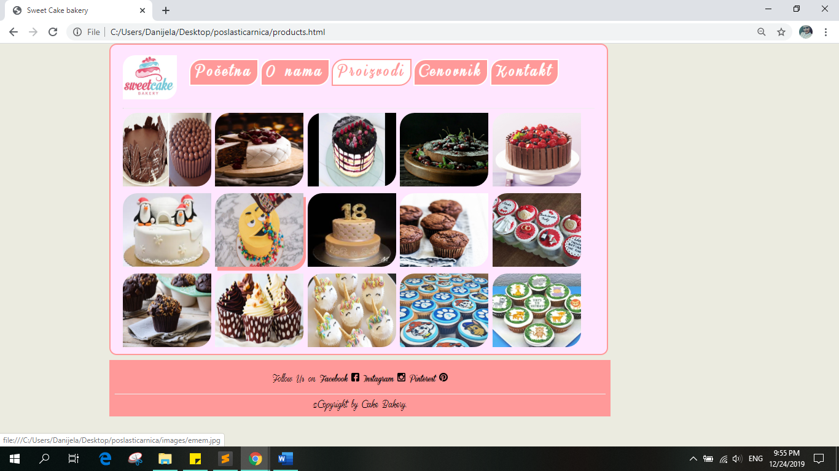

*Slika 3. proizvodi stranica*

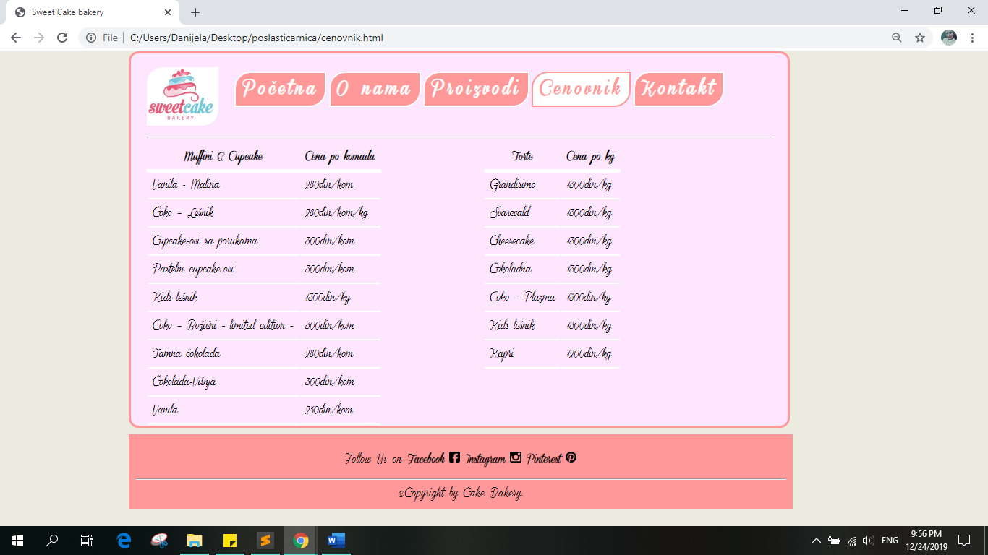

*Slika 4. cenovnik stranica*

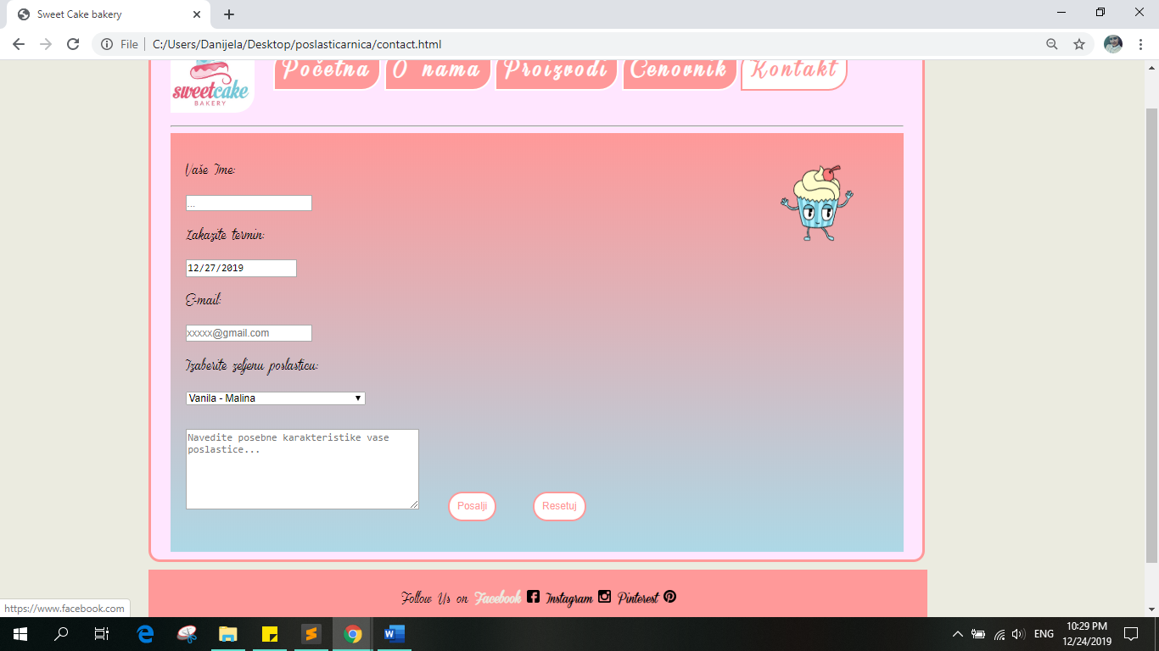

*Slika 5. Kontakt stranica*

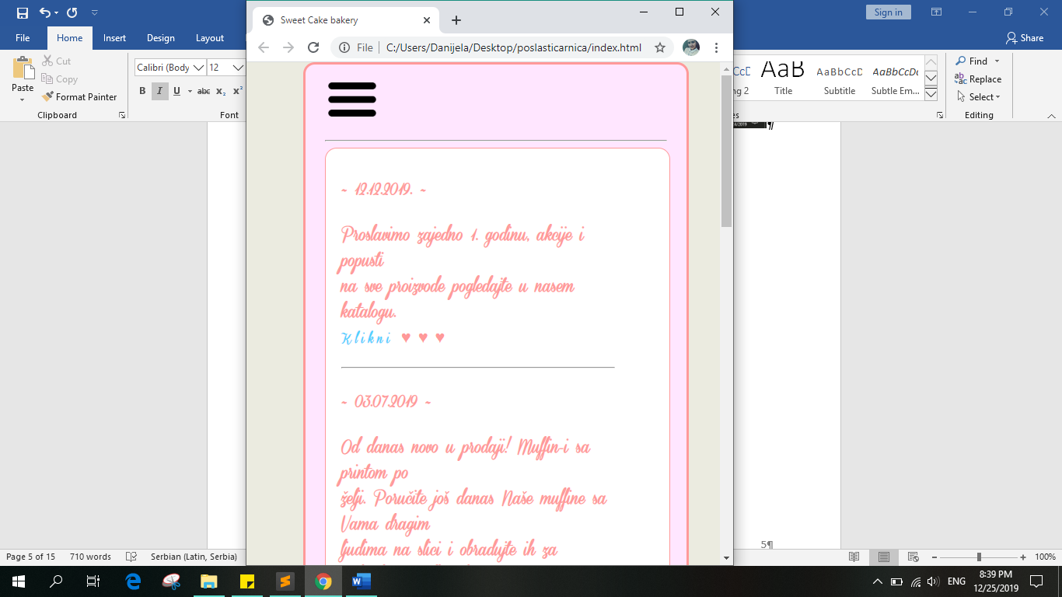

*Slika 6. stranica je responsivna*

Kod:

HTML

index.html

<!DOCTYPE html>

<html lang="en">

<head>

<meta charset="UTF-8">

<title>Sweet Cake bakery</title>

<link rel="stylesheet" href="stil/style.css">

<style>

@font-face{

font-family: kul;

src:url(Demo_ConeriaScript.ttf);

}

</style>

</head>

<body>

<div id="glavni">

<nav>

<img src="images/logo.jpg" id="logo">

<ul>

<a href="index.html"><li class="chosen">Početna</li></a>

<a href="onama.html"><li>O nama</li></a>

<a href="products.html"><li>Proizvodi</li></a>

<a href="cenovnik.html"><li>Cenovnik</li></a>

<a href="contact.html"><li>Kontakt</li></a>

</ul>

</nav>

<div class="padajuci">

<img src="images/ham.png" class="ham">

<div class="padajuciE">

<a href="index.html"><li>Početna</li></a>

<a href="onama.html"><li>O nama</li></a>

<a href="products.html"><li>Proizvodi</li></a>

<a href="cenovnik.html"><li>Cenovnik</li></a>

<a href="contact.html"><li>Kontakt</li></a>

</div>

</div>

<hr>

<section>

<article>

<h4>~ 12.12.2019. ~</h4>

<p class>Proslavimo zajedno 1. godinu, akcije i popusti<br> na sve proizvode pogledajte u nasem katalogu.<br><a href="katalog.pdf" class="linkovi">Klikni</a> ♥ ♥ ♥</p><hr>

<h4>~ 03.07.2019 ~</h4>

<p class>Od danas novo u prodaji! Muffin-i sa printom po<br> želji. Poručite još danas Naše muffine sa Vama dragim<br> ljudima na slici i obradujte ih za rođendan, svadbu, ili <br>drugo slavlje ♥ ♥ ♥</p><hr>

<h4>~ 17.01.2019. ~</h4>

<p class>Novo u nasoj ponudi, coko - plazma torta.<br>

Boja fondana po zelji. Pravimo razlicite dimenzije. ♥ ♥ ♥ </p><hr>

<h4>~ 12.12.2018. ~</h4>

<p class>Danas na sve torte popust radi otvaranja lokala.</p><hr>

<h4>~ 1.12.2018. ~</h4>

<p class>Otvaranje nove prodavnice u ulici Rumenacka 21. <br><b>12.12.2018. </b> Dodjite zajedno da proslavimo, bice <br> poklon pice, muzika, vaučeri... Čekamo Vas! ♥ ♥ ♥</p>

</article>

</section>

<aside>

Uskoro proširujemo naše područje rada. Ako misliš da si ti taj koga tražimo pošajli nam svoj CV na E-mail.

<a href="https://mail.google.com/" class="stranice">sweetbakery@gmail.com</a>

<hr>

<a href="https://www.instagram.com/" class="insta">

<p id="insta"> INSTAGRAM</p></a>

<img src="images/coko.jpg" class="asideslika">

<img src="images/muffin.jpg" class="asideslika">

<img src="images/mafin.jpg" class="asideslika">

<img src="images/vocna.jpg" class="asideslika">

</aside>

</div>

<footer>

<p>Follow Us on <a href="https://www.facebook.com/" class="stranice"> Facebook <img src="images/fb.png" class="simboli"></a>

<a href="https://www.instagram.com/" class="stranice"> Instagram <img src="images/insta.png" class="simboli"></a>

<a href="https://www.pinterest.com/" class="stranice"> Pinterest <img src="images/pinterest.png" class="simboli"></a>

</p>

<hr>

&copy;Copyright by Cake Bakery.</footer>

</body>

</html>

onama.html

<!DOCTYPE html>

<html lang="en">

<head>

<meta charset="UTF-8">

<title>Sweet Cake bakery</title>

<link rel="stylesheet" href="stil/style.css">

<style>

@font-face{

font-family: kul;

src:url(Demo_ConeriaScript.ttf);

}

</style>

</head>

<body>

<div id="glavni">

<nav>

<img src="images/logo.jpg" id="logo">

<ul>

<a href="index.html"><li>Početna</li></a>

<a href="onama.html"><li class="chosen">O nama</li></a>

<a href="products.html"><li>Proizvodi</li></a>

<a href="cenovnik.html"><li>Cenovnik</li></a>

<a href="contact.html"><li>Kontakt</li></a>

</ul><hr>

</nav>

<div class="about">Sweet Cake bakery je osnovana 12.12.2019. godine u Novom Sadu.

Počeli smo od torti raznih ukusa i dezena, pa se posao raširio i na muffine,razne kolače... Ispočetka je to bio porodični biznis, ali kako je sve brzo napredovalo bili su nam potrebni radnici i van porodice. Sada smo jedan tim koji dnevno može da napravi i do 50 torti raznih veličina i ukusa. posetite nas u Rumenačkoj 21. Čekamo Vas. ♥</div><br><br>

<img src="images/roditelji.jpg" class="glavni">

<img src="images/radnici.jpg" class="radnici">

</div>

<footer>

<p>Follow Us on <a href="https://www.facebook.com/" class="stranice"> Facebook <img src="images/fb.png" class="simboli"></a>

<a href="https://www.instagram.com/" class="stranice"> Instagram <img src="images/insta.png" class="simboli"></a>

<a href="https://www.pinterest.com/" class="stranice"> Pinterest <img src="images/pinterest.png" class="simboli"></a>

</p>

<hr>

&copy;Copyright by Cake Bakery.</footer>

</body>

</html>

products.html

<!DOCTYPE html>

<html lang="en">

<head>

<meta charset="UTF-8">

<title>Sweet Cake bakery</title>

<link rel="stylesheet" href="stil/style.css">

<style>

@font-face{

font-family: kul;

src:url(Demo_ConeriaScript.ttf);

}

</style>

</head>

<body>

<div id="glavni">

<nav>

<img src="images/logo.jpg" id="logo">

<ul>

<a href="index.html"><li >Početna</li></a>

<a href="onama.html"><li>O nama</li></a>

<a href="products.html">

<li class="chosen">Proizvodi</li></a>

<a href="cenovnik.html"><li>Cenovnik</li></a>

<a href="contact.html"><li>Kontakt</li></a>

</ul>

</nav> <hr>

<div id="galerija">

<a href="images/coko.jpg"><img src="images/coko.jpg" class="produkti"></a>

<a href="images/svarcvald.jpg"><img src="images/svarcvald.jpg" class="produkti"></a>

<a href="images/vocna.jpg"><img src="images/vocna.jpg" class="produkti"></a>

<a href="images/cizkejk.jpg"><img src="images/cizkejk.jpg" class="produkti"></a>

<a href="images/coko-vocna.jpg"><img src="images/coko-vocna.jpg" class="produkti"></a>

<a href="images/decija.jpg"><img src="images/decija.jpg" class="produkti"></a>

<a href="images/emem.jpg"><img src="images/emem.jpg" class="produkti"></a>

<a href="images/fondan.jpg"><img src="images/fondan.jpg" class="produkti"></a>

<a href="images/muffin.jpg"><img src="images/muffin.jpg" class="produkti"></a>

<a href="images/mafin.jpg"><img src="images/mafin.jpg" class="produkti"></a>

<a href="images/dark.jpg"><img src="images/dark.jpg" class="produkti"></a>

<a href="images/sareni.jpg"><img src="images/sareni.jpg" class="produkti"></a>

<a href="images/cute.jpg"><img src="images/cute.jpg" class="produkti"></a>

<a href="images/saslikom.jpg"><img src="images/saslikom.jpg" class="produkti"></a>

<a href="images/animals.jpg"><img src="images/animals.jpg" class="produkti"></a>

</div>

</div>

<footer>

<p>Follow Us on <a href="https://www.facebook.com/" class="stranice"> Facebook <img src="images/fb.png" class="simboli"></a>

<a href="https://www.instagram.com/" class="stranice"> Instagram <img src="images/insta.png" class="simboli"></a>

<a href="https://www.pinterest.com/" class="stranice"> Pinterest <img src="images/pinterest.png" class="simboli"></a>

</p>

<hr>

&copy;Copyright by Cake Bakery.</footer>

</body>

</html>

cenovnik.html

<!DOCTYPE html>

<html lang="en">

<head>

<meta charset="UTF-8">

<title>Sweet Cake bakery</title>

<link rel="stylesheet" href="stil/style.css">

<style>

@font-face{

font-family: kul;

src:url(Demo_ConeriaScript.ttf);}

</style>

</head>

<body>

<div id="glavni">

<nav>

<img src="images/logo.jpg" id="logo">

<ul>

<a href="index.html"><li>Početna</li></a>

<a href="onama.html"><li>O nama</li></a>

<a href="products.html"><li>Proizvodi</li></a>

<a href="cenovnik.html">

<li class="chosen">Cenovnik</li></a>

<a href="contact.html"><li>Kontakt</li></a>

</ul>

</nav><hr>

<div>

<table id="mafini">

<tr>

<th>Muffini & Cupcake</th>

<th>Cena po komadu</th>

</tr>

<tr>

<td>Vanila - Malina</td>

<td>280din/kom</td>

</tr>

<tr>

<td>Čoko – Lešnik</td>

<td>280din/kom/kg</td>

</tr>

<tr>

<td>Cupcake-ovi sa porukama</td>

<td>300din/kom</td>

</tr>

<tr>

<td>Pastelni cupcake-ovi</td>

<td>300din/kom</td>

</tr>

<tr>

<td>Kids lešnik</td>

<td>1300din/kg</td>

</tr>

<tr>

<td>Čoko – Božićni ~ limited edition ~ </td>

<td>300din/kom</td>

</tr>

<tr>

<td>Tamna čokolada</td>

<td>280din/kom</td>

</tr>

<tr>

<td>Čokolada-Višnja </td>

<td>300din/kom</td>

</tr>

<tr>

<td>Vanila</td>

<td>250din/kom</td>

</tr>

</table>

<table id="torte">

<tr>

<th>Torte</th>

<th>Cena po kg</th>

</tr>

<tr>

<td>Grandisimo</td>

<td>1300din/kg</td>

</tr>

<tr>

<td>Švarcvald</td>

<td>1300din/kg</td>

</tr>

<tr>

<td>Cheesecake</td>

<td>1300din/kg</td>

</tr>

<tr>

<td>Čokoladna</td>

<td>1300din/kg</td>

</tr>

<tr>

<td>Čoko – Plazma</td>

<td>1500din/kg</td>

</tr>

<tr>

<td>Kids lešnik</td>

<td>1300din/kg</td>

</tr>

<tr>

<td>Kapri</td>

<td>1200din/kg</td>

</tr>

</table>

</div>

</div>

<footer>

<p>Follow Us on <a href="https://www.facebook.com/" class="stranice"> Facebook <img src="images/fb.png" class="simboli"></a>

<a href="https://www.instagram.com/" class="stranice"> Instagram <img src="images/insta.png" class="simboli"></a>

<a href="https://www.pinterest.com/" class="stranice"> Pinterest <img src="images/pinterest.png" class="simboli"></a>

</p>

<hr>

&copy;Copyright by Cake Bakery.</footer>

</body>

</html>

contact.html

<!DOCTYPE html>

<html lang="en">

<head>

<meta charset="UTF-8">

<title>Sweet Cake bakery</title>

<link rel="stylesheet" href="stil/style.css">

<style>

@font-face{

font-family: kul;

src:url(Demo_ConeriaScript.ttf);

}

</style>

</head>

<body>

<div id="glavni">

<nav>

<img src="images/logo.jpg" id="logo">

<ul>

<a href="index.html"><li>Početna</li></a>

<a href="onama.html"><li>O nama</li></a>

<a href="products.html"><li>Proizvodi</li></a>

<a href="cenovnik.html"><li>Cenovnik</li></a>

<a href="contact.html">

<li class="chosen">Kontakt</li></a>

</ul>

</nav><hr>

<img src="images/anim.gif" id="animacija">

<div class="forma">

<form id="kontaktforma">

<p>Vaše Ime:</p><input type="text" placeholder="...">

<p>Zakazite termin:</p><input type="date" value="2019-12-27">

<p>E-mail:</p><input type="email" placeholder="xxxxx@gmail.com">

<p>Izaberite zeljenu poslasticu:</p>

<select>

<optgroup label="Muffini & Cupcake">

<option>Vanila - Malina</option>

<option>Čoko – Lešnik</option>

<option>Cupcake-ovi sa porukama</option>

<option>Pastelni cupcake-ovi</option>

<option>Kids lešnik</option>

<option>Čoko – Božićni ~ limited edition ~ </option>

<option>Tamna čokolada</option>

<option>Čokolada-Višnja</option>

<option>Vanila</option>

</optgroup>

<optgroup label="Torte">

<option>Grandisimo</option>

<option>Švarcvald</option>

<option>Cheesecake</option>

<option>Čokoladna</option>

<option>Čoko – Plazma</option>

<option>Kids lešnik</option>

<option>Kapri</option>

</optgroup>

</select><br><br>

<textarea placeholder="Navedite posebne karakteristike vase poslastice..."></textarea>

<input type="submit" value="Posalji" class="dugmici">

<input type="reset" value="Resetuj" class="dugmici">

</form>

</div>

</div>

<footer>

<p>Follow Us on <a href="https://www.facebook.com/" class="stranice"> Facebook <img src="images/fb.png" class="simboli"></a>

<a href="https://www.instagram.com/" class="stranice"> Instagram <img src="images/insta.png" class="simboli"></a>

<a href="https://www.pinterest.com/" class="stranice"> Pinterest <img src="images/pinterest.png" class="simboli"></a>

</p>

<hr>

&copy;Copyright by Cake Bakery.</footer>

</body>

</html>

CSS:

body{

background-color: #ebebe0;

padding:0px;

margin:0% 12%;

font-family: kul;

}

.chosen{

background-color: white;

color: #ff9999;

border-color: #ff9999;

}

#logo{

width:110px;

height:90px;

display: inline;

border-radius: 25px 0px 25px 0px;

}

ul{

padding:10px 15px;

display:inline-block;

}

li{

list-style-type: none;

float:left;

border: 2px solid white;

margin:2px;

padding:5px 10px;

border-radius: 25px 0px 25px 0px;

background-color: #ff9999;

}

a{

color:white;

font-weight: bold;

letter-spacing: 5px;

font-size: 25px;

text-decoration: none;

}

li:hover{

background-color:white;

color:#ff9999;

border: 2px solid #ff9999;

}

.linkovi{

color:#4dd2ff;

font-weight: bold;

font-size: 15px;

}

.linkovi:hover{

border:2px solid #4dd2ff;

border-radius:90%;

padding:5px;

font-size: 1em;

}

#insta{

color:#ff9999;

font-size:18px;

border: 2px solid #ff9999;

border-radius: 15px;

padding:5px;

font-family: kul;

letter-spacing:3px;

margin:25px 20%;

}

#insta:hover{

color:white;

background-color: #ff9999;

}

.asideslika{

height: 100px;

width:120px;

border-radius: 25px;

border:2px solid #ff9999;

}

#glavni{

width:95%;

border:3px solid #ff9999;

background-color: #ffe6ff;

padding: 10px 25px;

border-radius: 15px;

}

section{

display:inline-block;

}

article{

float:left;

width:80%;

padding: 10px 70px 10px 20px;

font-size: 20px;

background-color: white;

font-weight: bold;

color:#ff9999;

border:1px solid #ff9999;

border-radius: 15px;

}

aside{

background-color: white;

color:#ff9999;

font-weight: bold;

width:270px;

display:inline-block;

float:right;

border: 3px solid #ff9999;

padding:15px 10px;

border-radius:15px;

}

footer{

clear:both;

width:100%;

margin-top:10px;

margin-bottom:10px;

padding:10px;

background-color: #ff9999;

text-align:center;

}

.stranice{

color:black;

letter-spacing:0px;

font-size:15px;

}

.simboli{

height:17px;

width:17px;

color:black;

}

.simboli,.stranice:hover{

color: #ebebe0;

font-size:1em;

}

.about{

display:inline-block;

border:2px solid #ff9999;

padding:15px 20px;

background-color: white;

margin-bottom:10px;

}

.glavni{

margin-left:200px;

height:200px;

width: 170px;

border-radius: 20px;

}

.radnici{

margin-left:50px;

height:200px;

width:300px;

border-radius:20px;

}

.produkti{

height:150px;

width:180px;

border-radius:30px 0px 30px 0px;

}

.produkti:hover{box-shadow: 5px 8px #ff9999;}

#torte, #mafini{

border-bottom:5px solid white;

display:inline;

margin-right:150px;

margin-bottom:15px;

font-size:15px;

}

th,td{

padding:8px;

border-bottom:2px solid white;

}

.ham{

width:70px;

}

nav{

display:none;

}

.padajuci {

position: relative;

display: inline-block;

}

.padajuciE {

display: none;

position: absolute;

background-color: white;

border-color:#ff9999;

min-width: 150px;

z-index:10;

}

.padajuciE a {

color: white;

padding: 5px 10px;

text-decoration: none;

display: block;

text-decoration: italic;

}

.padajuci:hover .padajuciE {display: block;}

@media screen and (min-width:650px){

nav{display:inline;}

.ham{display:none;}

.padajuciE{display:none;}

}

@media screen and (max-width:600px){

nav{display: none;}

.ham{display: inline;}

body{margin:0px 5px;}

aside{display:inline-block;}

.asideslika{display:none;}

article{width:350px;}}

.forma{

background-image:linear-gradient(#ff9999,lightblue);

padding:20px;

}

#kontaktforma{

display:inline;

width:900px;

height: 550px;

}

input[type=text], input[type=email], select{

border:2px solid silver;

padding:12px;

border-radius: 5px 20px;

width:45%;

}

textarea{

width:45%;

height: 100px;

border-radius: 20px;

padding:10px;

}

.dugmici{

border:2px solid #ff9999;

background:white;

color:#ff9999;

border-radius:45px;

margin-bottom:20px;

margin-left:30px;

margin-right:10px;

padding:10px;

font-size:27px:;

}

.dugmici:hover{

border:2px solid white;

background-color: #ff9999;

color:white;

font-size: 1em;

}

#animacija{

display:inline;

position:relative;

top:30px;

right:50px;

float:right;

height:120px;

width:120px;

animation:Animacija 5s 3;

}

@keyframes Animacija{

0%{top:30px; right:50px;}

50%{ top:380px; right:50px;}

100%{top:30px; right:50px;}

}